

# WEB TECHNOLOGIES MINI PROJECT REPORT

**ON**

**(TRANSPORT MANGMENT SYSTEM)**

SUBMITTED TO

### D, Y. Patil Institute of MCAM, Akurdi,Pune-44.

**BY**

Ajith Kumar 27

Sunil Kumar Yadav 51

As a Partial Fulfillment Of

**Master Of Computer Applications Savitribai Phule Pune University** Academic Year 2018-19

Dr. D. Y. Patil Pratishthan’s

**D. Y. Patil Institute of Master of Computer Applications and Management**

Sector No.29, Behind Akurdi Railway Station, Pradhikaran, Nigdi, Pune – 411044 [Tel No: 020-27640998, 202737393, Fax no: 27653054,Website: www.dypimca.ac.in,](http://www.dypimca.ac.in/) Email: [director@dypimca.ac.in](mailto:director@dypimca.ac.in)

**(Approved by AICTE, Recognized by DTE, Mah.; Affiliated to SPPU )**

**Certificate**

This is to certify that Mr. / Ms. **Ajith Kumar ,Sunil Kumar Yadav**

Roll No. **27,51** has satisfactorily completed **Mini Project** Titled As

## **Transport Management System** towards Partial Fulfillment of **Web Technologies** as per the syllabus laid down by the Savitribai Phule Pune University for MCA I year Semester II during the academic year 2018 – 2019.

Snehal Patil, Dr. Balasaheb Bhamangol, Ms. Sheetal Patil

**(WT Mini Project Guides)**

Dr. K Nirmala

**(Director)**

**Date:**

**Place:**

**INDEX**

|  |  |  |
| --- | --- | --- |
| **Sr. No** | **Chapter Name** | **Page No.** |
| 1 | **Chapter 1: Introduction** |  |
| 1.1) Existing System |  |
| 1.2) Scope of Work  1.3) Software and Hardware Requirements : |  |
| 2 | **Chapter 2**: **Proposed System** |  |
| 2.1) Proposed System |  |
| 2.2) Objectives of System |  |
| 2.3) Module Specification |  |
| 2.4) User Requirements |  |
| 3 | **Chapter 3**: **Analysis & Design** |  |
| 3.1) Entity Relationship Diagram |  |
| 3.2) DFD (CLD, 1st level, 2nd level) |  |
| 3.5) Table Design  [Sr no. Name, Type, Size ,Constraint, Description ] |  |
| 4 | **Chapter 4: User Manual** |  |
| 4.1) User Manual |  |
| 5 | **Drawbacks and Limitation** |  |
| 6 | **Future Enhancements** |  |
| 7 | **Conclusions** |  |
| 8 | **Bibliography** |  |
| 9 | **Annexures** |  |
| Annexures 1:Home Page |  |
| Annexures 2 : Input Forms With Data  (Input screen With Validations)(add 5 static & 5 dynamic pages) |  |
| Annexures 3: Output Reports With Data |  |
| Annexures 4: Sample Code |  |

**ACKNOWLEDGEMENT**

I would take the opportunity to thank **Dr. K Nirmala, Director, DYPIMCAM for** her support, extended to me throughout the course. I would like to thank **Dr. Kavita Suryawanshi, HOD,MCA**, for her scholarly disposition, timely guidance, support and cooperation.

I would like to thank **Snehal Patil** , for his/**her** kind guidance, keen interest, continuous encouragement and inspiration throughout the project work.

Also wholeheartedly express thankfulness to **Snehal Patil** for her, enthusiasm and

advice.

Finally, I gratefully thank all the staff members of DYPIMCAM for their cooperation and

support.

I also thankful to get constant encouragement, support and guidance from all Teaching and Non- Teaching Staff for their timely support which helped us in successfully completion of our project work.

**RollNo:27,51**

**Student Name: Ajith Kumar,Sunil Kumar yadav Signature**

**Introduction**

Hari Om Logistics is a company which does the process of planning, implementing, and controlling the efficient, effective flow and storage of goods, services, transport, and related information from point of origin to point of consumption for the purpose of conforming to customer requirements.“

Hari Om Logistics is the management of the transport of goods, information and other resources, including energy and people, between the point of origin and the point of consumption in order to meet the requirements of consumers.

Hari Om Logistics involves the integration of information, transportation, inventory, warehousing, material-handling, and packaging, and occasionally security.

The logistics and transportation activities are moving towards the centre stage world around and becoming the most critical business function in today’s world of immense competition. Today, quickest and efficient supply chain management is the key success factor for many business sectors.

Surface transport still rules as the most widely used mode of logistics in our country. It’s high time; the transportation companies switch to futuristic technology solutions to manage the ever growing industry requirements and never ending customer demands. The solutions that move beyond just logics, towards being efficient, cost effective and quick.

**Existing system**

There is no computerized provision in the company to maintain all the trip details that are taking within the company. All the customer order are being handled manually.

A customer has to come up to the company personally to book a vehicle or to send a parcel.   
All the order details are also being maintained manually.

The labor work is too much and no proper maintenance is taking place in the existing system.

**Problems in Existing System**

* A considerable amount of effort, time and resources are involved due to manual processing can be achieved.
* No proper control over collection of data.

**Scope**

The logistics and transportation activities are moving towards the centre stage world around and becoming the most critical business function in today’s world of immense competition. Today, quickest and efficient supply chain management is the key success factor for many business sectors.

Surface transport still rules as the most widely used mode of logistics in our country. It’s high time; the transportation companies switch to futuristic technology solutions to manage the ever growing industry requirements and never ending customer demands. The solutions that move beyond just logics, towards being efficient, cost effective and quick.

**Software and Hardware Requirements :**

**Hardware:**

Processor : Intel I3 or above.

Ram : 1 GB or above.

HDD: 300 GB or above.

**Software :**

Operating system : Windows 7 or above.

Web Browser: Chrome , Mozila , Firefox ect.

Development tools: HTML,JSP,ASP.

Database: Microsoft Access.

**Proposed System**

The proposed system will record the order details as well as the customer details, and generate an appropriate Invoice to be presented to the Customer for order confirmation.

The appropriate transport facilities must be set. The proposed system displays all the vehicles information that are available for delivery. It then allows the Admin to select the vehicle and assign driver for the door delivery and records all the information . The proposed system displays a Door Delivery form in which the administrator can add all the information regarding the vehicle, and the customer details to whom the product has to be delivered.

**Objectives of System**

This project deals with the ‘Transport management’. The system is used for daily activities such as booking, sending parcel, out return, company details, hub rates, and pickup centers. It is very difficult to do this process manually. Hence it is recommended to computerize the process by developing the relative software as the world is turning into information and technology; computerization becomes necessity in all walks of life.

HOL is a web based Transport Management System which supports the high availability of transport services to the business and to the customer. The system is being used for day to day activities such as sending a parcel, maintain hub details, maintain company details, process data of companies and many other things.

**2.3 Module Specification:**

Customer: Customer module includes registration and login through that user can book vehicle and send parcel also will have a track on his orders.

Admin: Admin module includes login through that he can update, delete & also can keep a track on his customers, drivers and vehicles.

**2.4 User Requirements:**

User wants a reliable and user-friendly system with accurate and efficientinformation provided by the system. This is the main requirement of the user. As far as possible the input screens format should match with the input document. But for the adjustment of space on the screen, if the screen format is changed, at least sequence of reading the values from input form and feeding them to the screen must be maintained. The proper report format is to be prepared according to need. Security of data must be provided using logins.

**Chapter 3**: **Analysis & Design**

**3.1 Entity Relationship Diagram:**

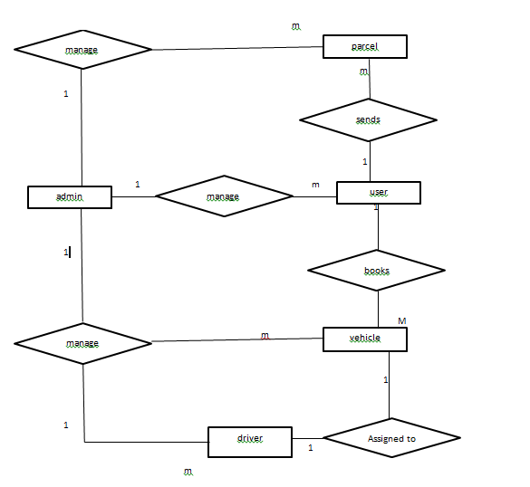

**3.2 Data Flow Diagram:**

**Level 1 DFD**

Customer detail’s customer detail,s book vehicle or parsel

Admin

Customer

Customer detail’s

customer detail,s book vehicle or parsel

**Level 2 DFD**

ADMIN

USER

**User send parsel or book vehicle**

**Admin checks and update data**

**User register**

GUEST USER

**3.3 Table Designing:**

**User’s Table.**

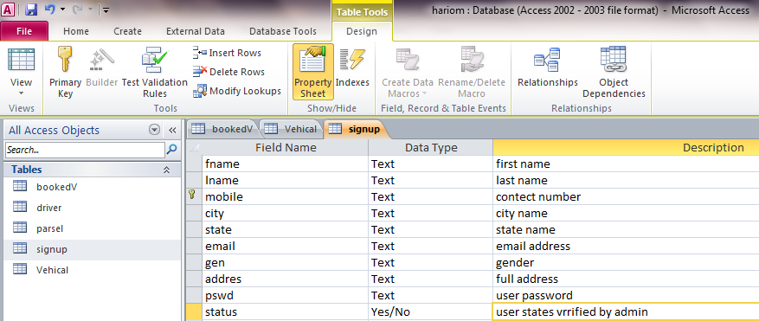

**Driver’s table**

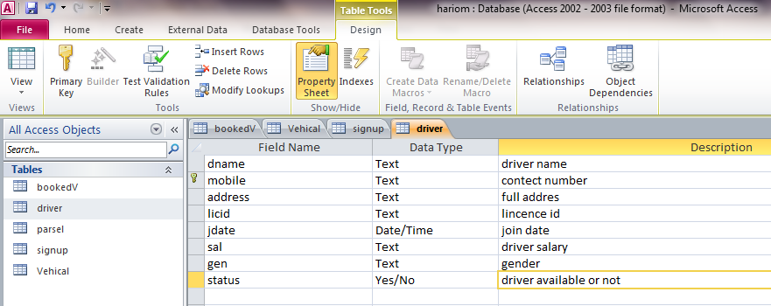

**Parcel Table.**

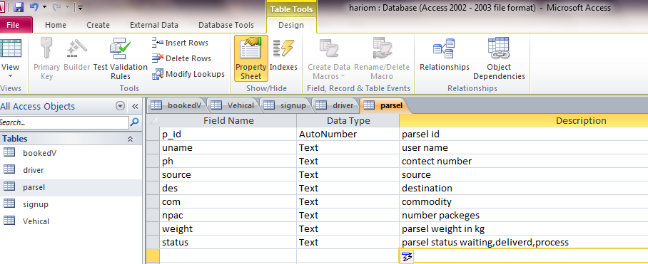

**Vehicle table**

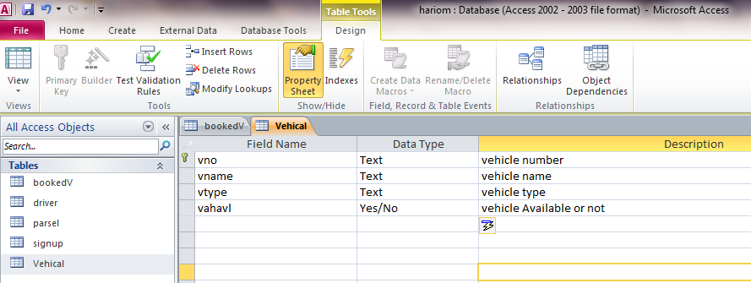

**Booked Vehicles Tables**

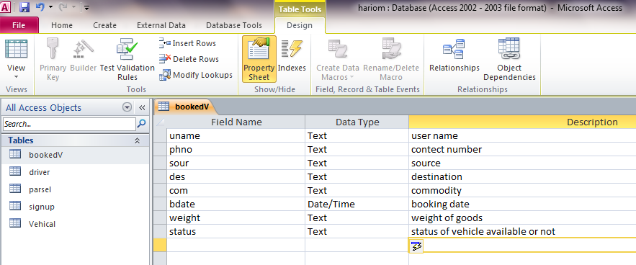

**Chapter 4: User Manual**

**4.1 User Manual:**

User should first signup on the website. Also there are some pages which can be accessed before registering also. After registering on the website user can book vehicles and send parcels. He can click the menus to visit particular page. He can view which some details about the company and also check the status of the order and also can update the his details.

**5 Drawbacks and Limitation:**

Free version or completely free website is available in all categories with their own advantage and disadvantage. The real benefit of website is always packed in a pro version. Here in this article, let us discuss the pros and cons of setting up a school website at free of cost.

The first visible difference between the two is the technical support rendered over phone or email and even with remote assistance. Many online logistics management system appoint personnel who give remote support to instruct customers on the go to use the software to the fullest. This feature is perhaps a greatest missing factor in free version of website.

**6 Future Enhancements:**

The project school website is flexible enough to meet the requirements of users and customers.

* Check Status.
* Update Details.
* Track Of Parcel.
* Updates in designing etc.

**7 Conclusions:**

In conclusion, transportation system is important to urban and social development. The roles of urban transport explained above are important to affect the demand and supply of urban land market. Transportation systems influence virtually every aspect of community life. They are the means for moving people, goods and services throughout communities, the region, and, increasingly, to destinations around the world. Of equal importance, these systems have played a significant role in shaping patterns of growth, facilitating economic prosperity, and influencing the character and livability of our communities. As a result, transportation planning is a particularly important component in the overall planning for what we want our communities to be.

To sum up, it is recommended that road network in a city should be planned in an integrated manner along with the public transport network. Broad cross-section is recommended to be reorganized for equitable allocation of road space. Missing links and opening up of dead end roads should be given priority too. Expansion of road network in a city should be minimal, and primarily for providing access to urban areas, in order to avoid attracting vehicular traffic and resulting congestion. The stated improvement can really help in solving the transportation problem. It will help in increasing the demand of people towards the land at the area and therefore can create higher land value and better development.

**8 Bibliography:**

<https://www.w3schools.com/css/default.asp>

<https://www.w3schools.com/js/default.asp>

<https://www.w3schools.com/html/default.asp>

<https://www.w3schools.com/asp/>

**User Home Page**

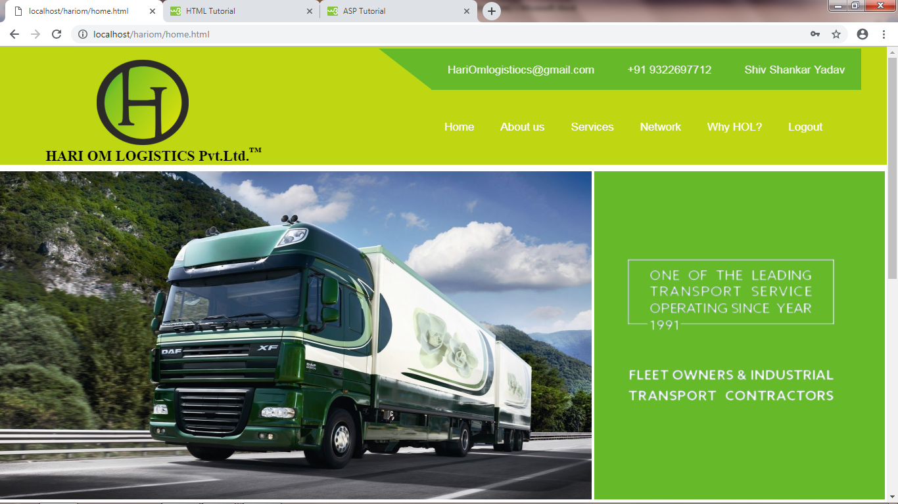

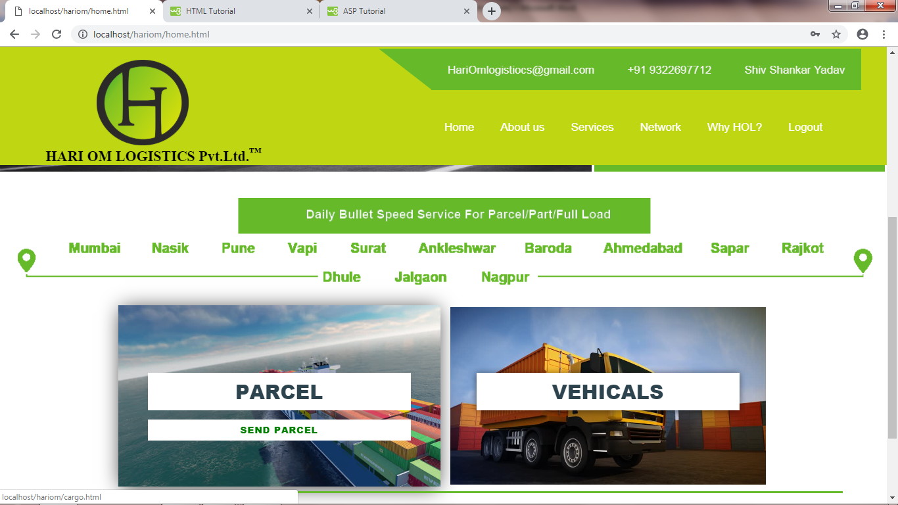

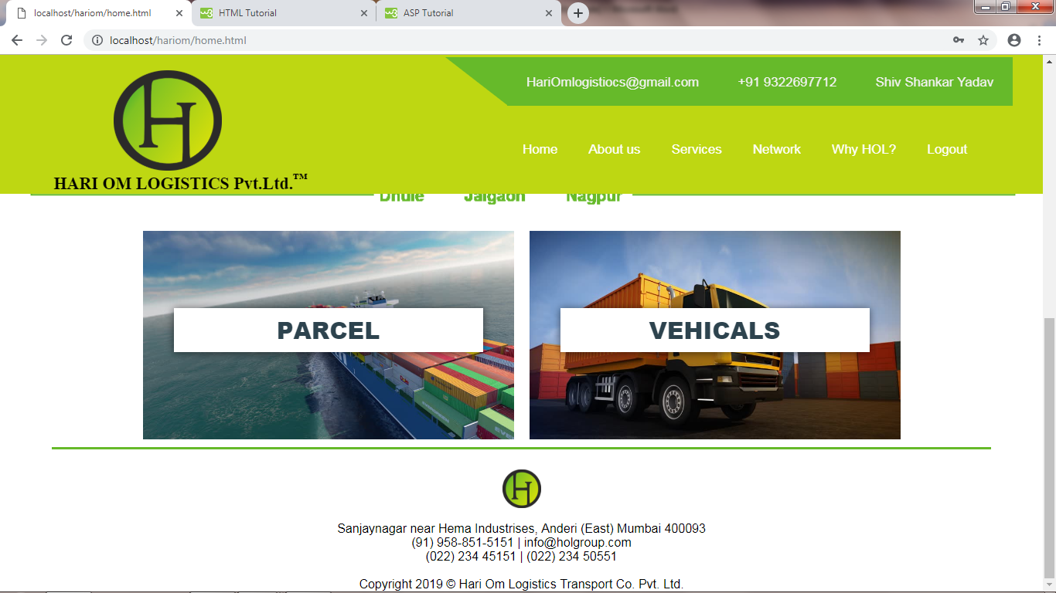

**Admin Home Page**

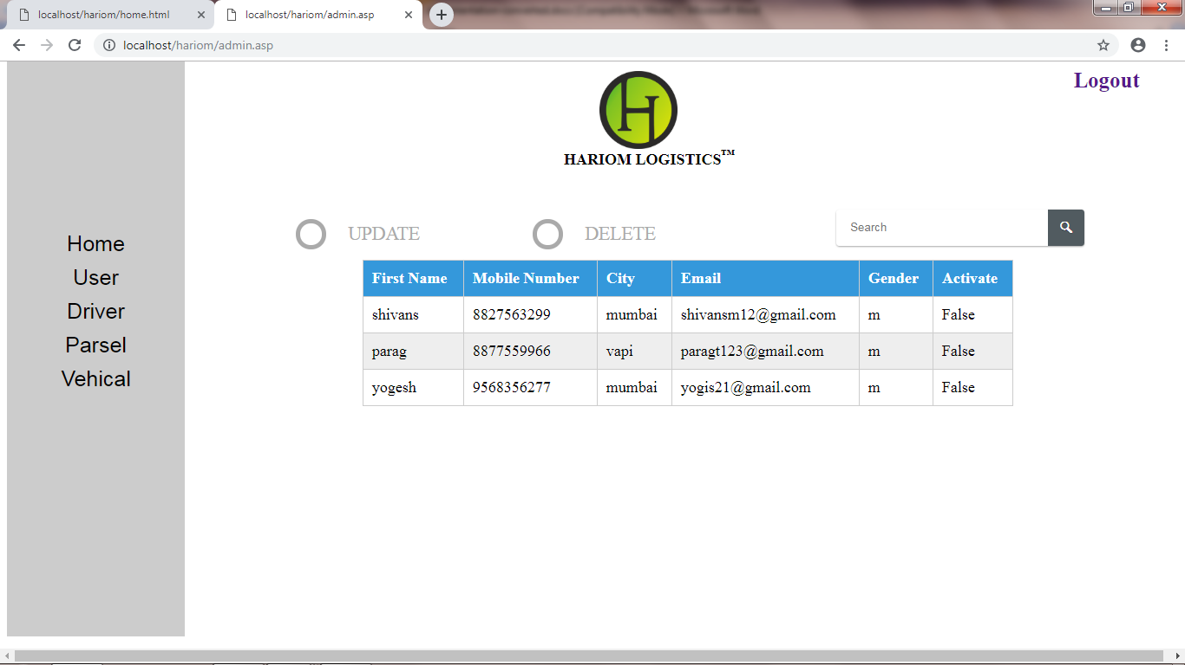

**Login Page**

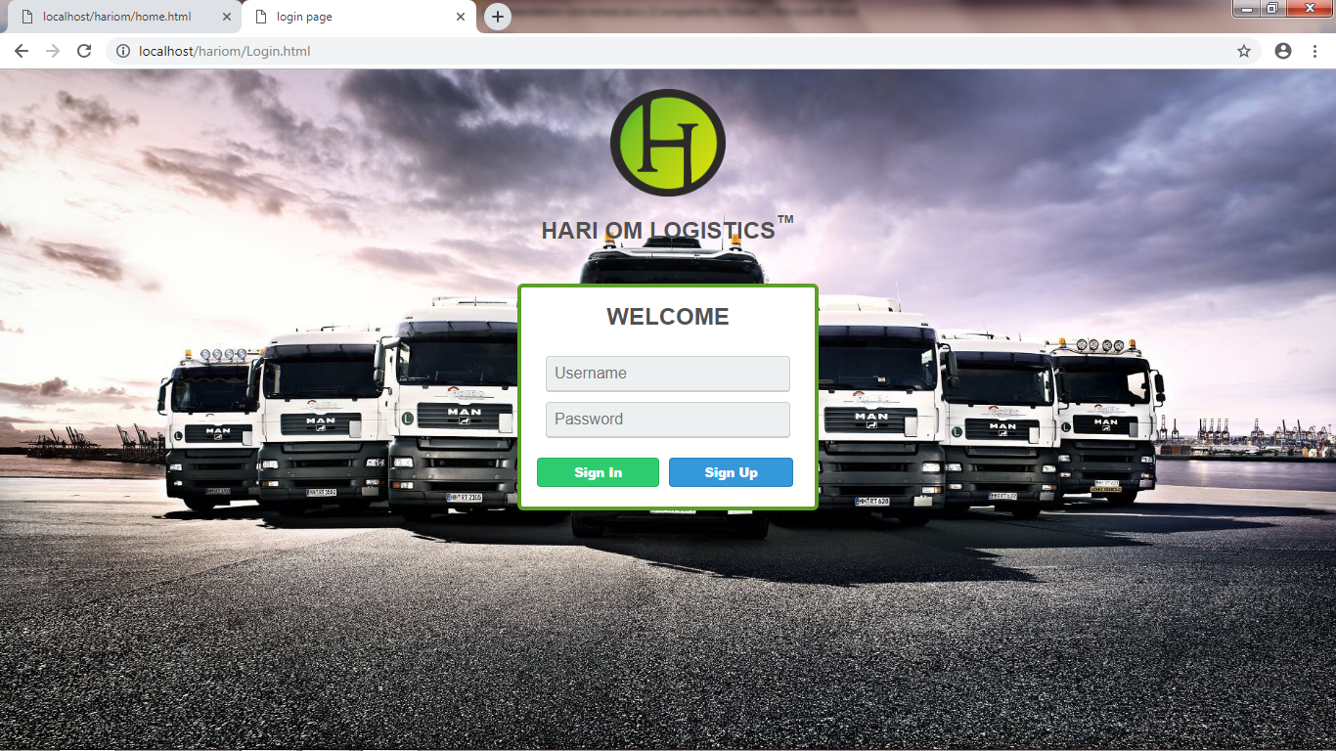

**Registration Page (User)**

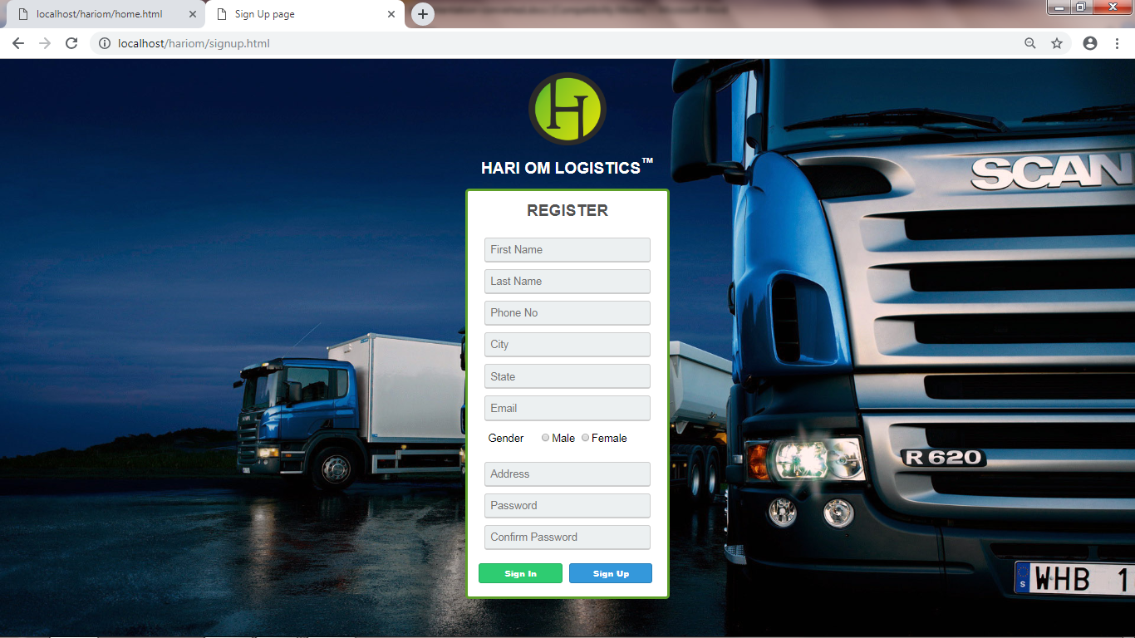

**Send Parcel Page (User)**

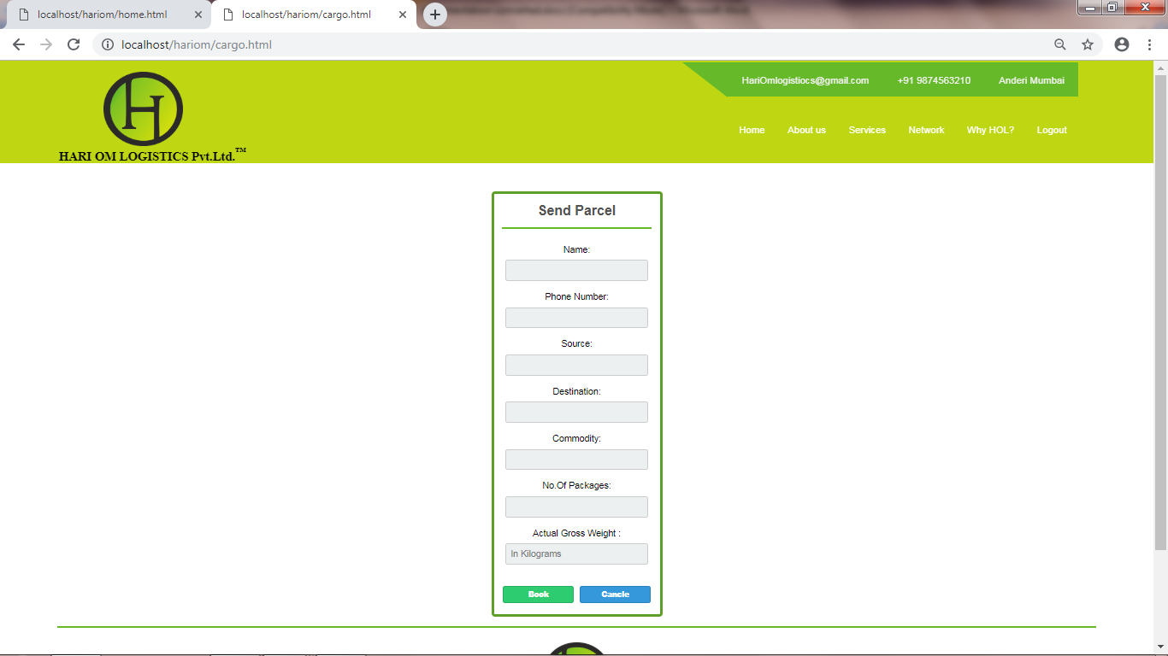

**Book Vehicle page (User)**

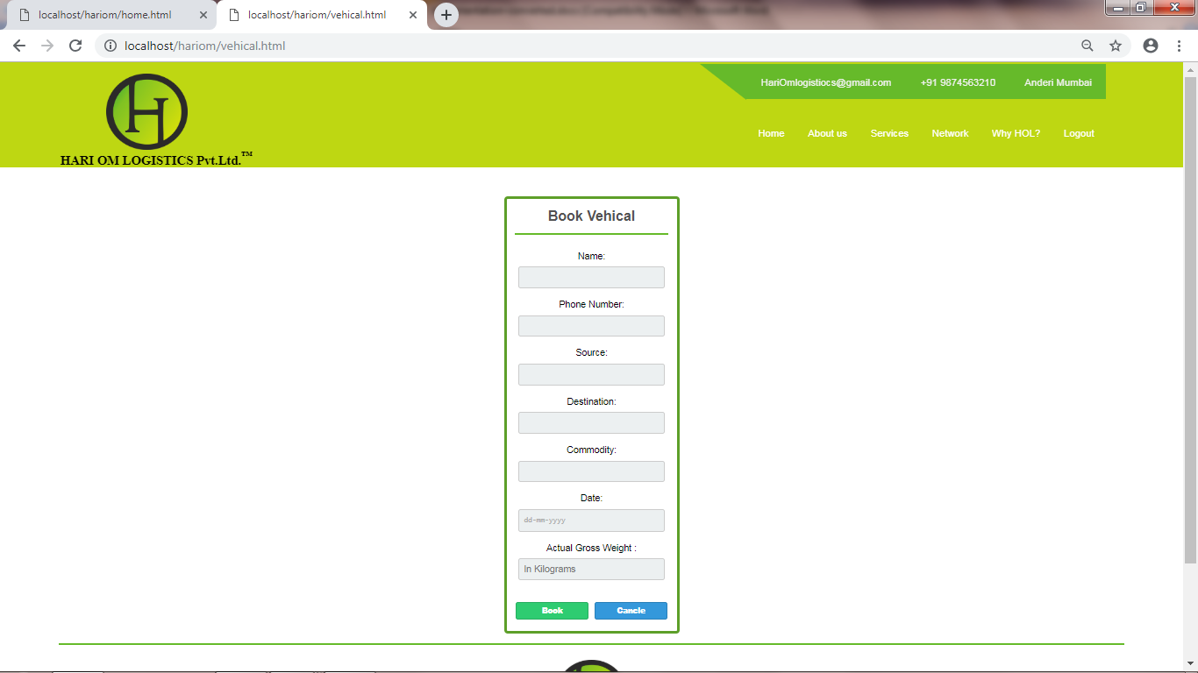

**Add User Page (Admin)**

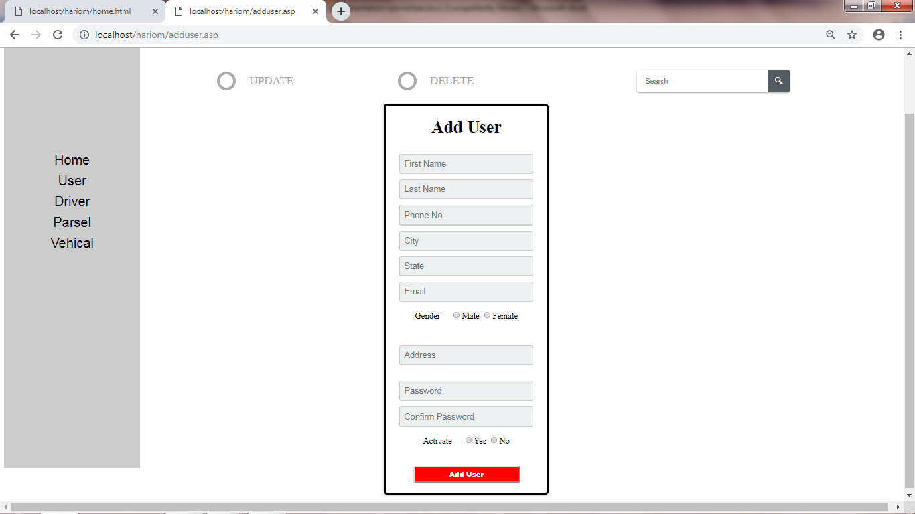

**Add Driver Page (Admin)**

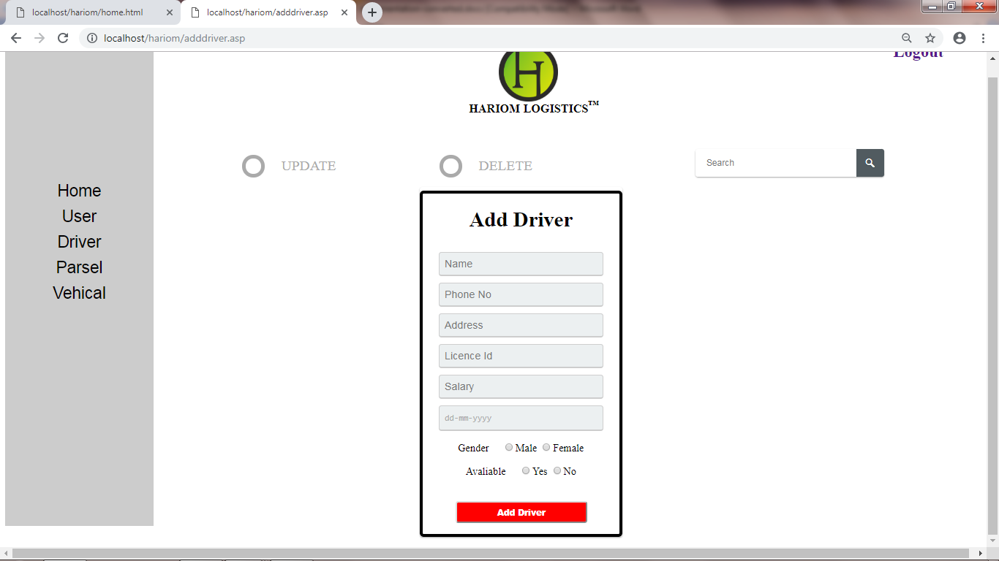

**Add Vehicle Page (Admin)**

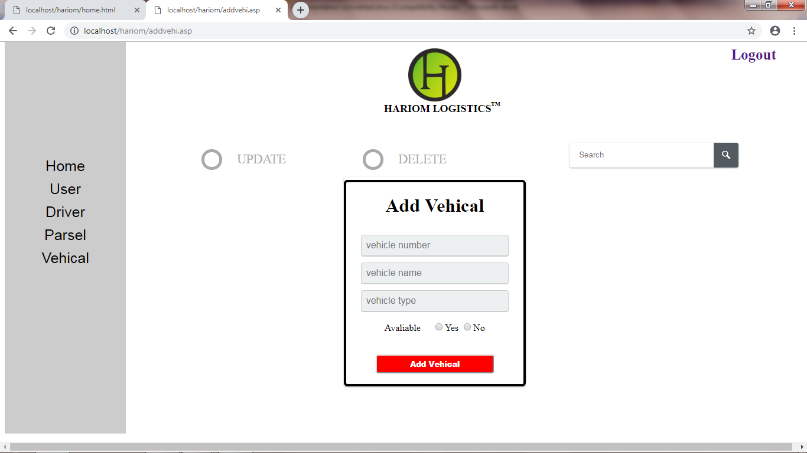

**Non Active Users (Admin)**

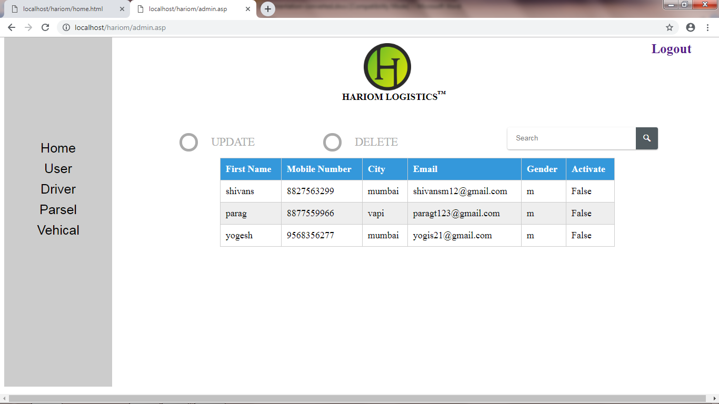

**User Details (Admin)**

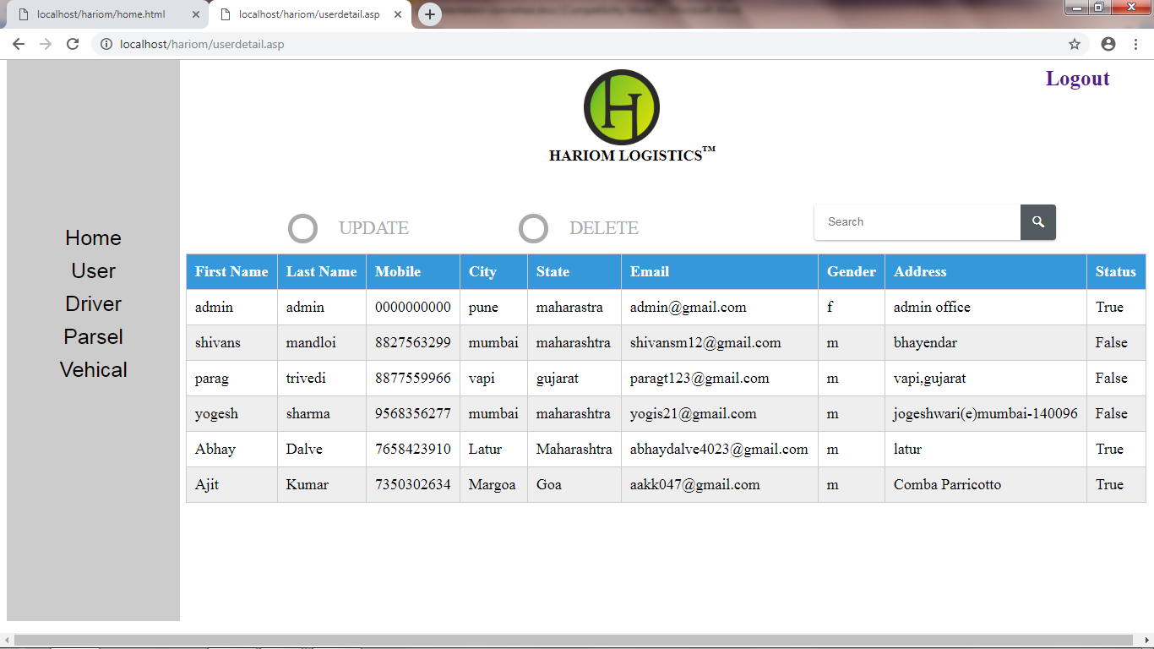

**Driver Details (Admin)**

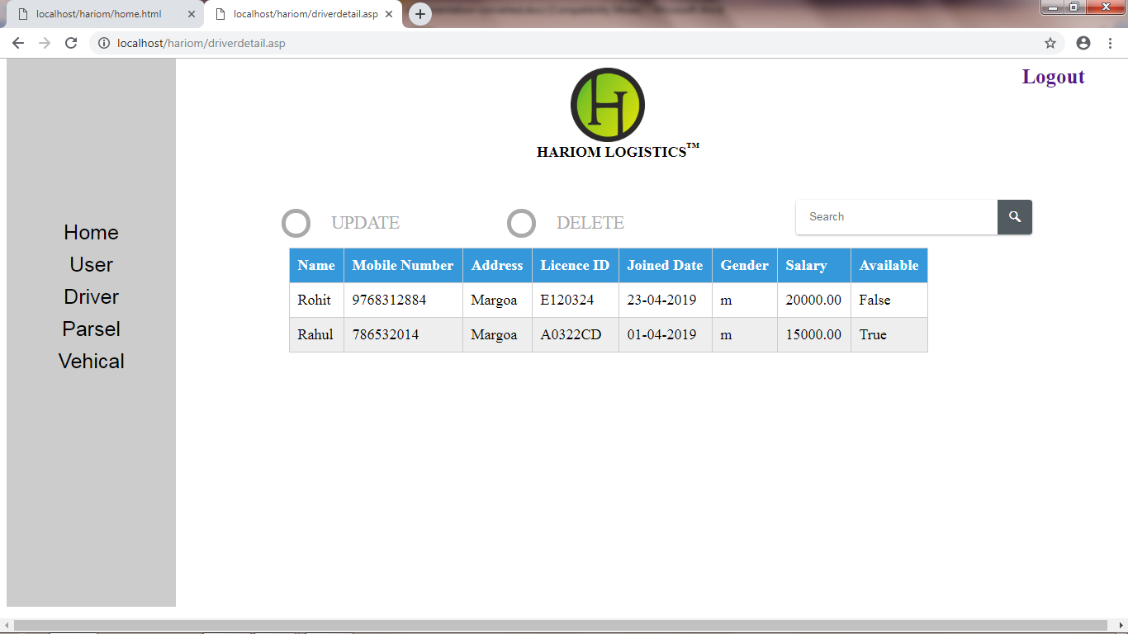

**Parcel Details (admin)**

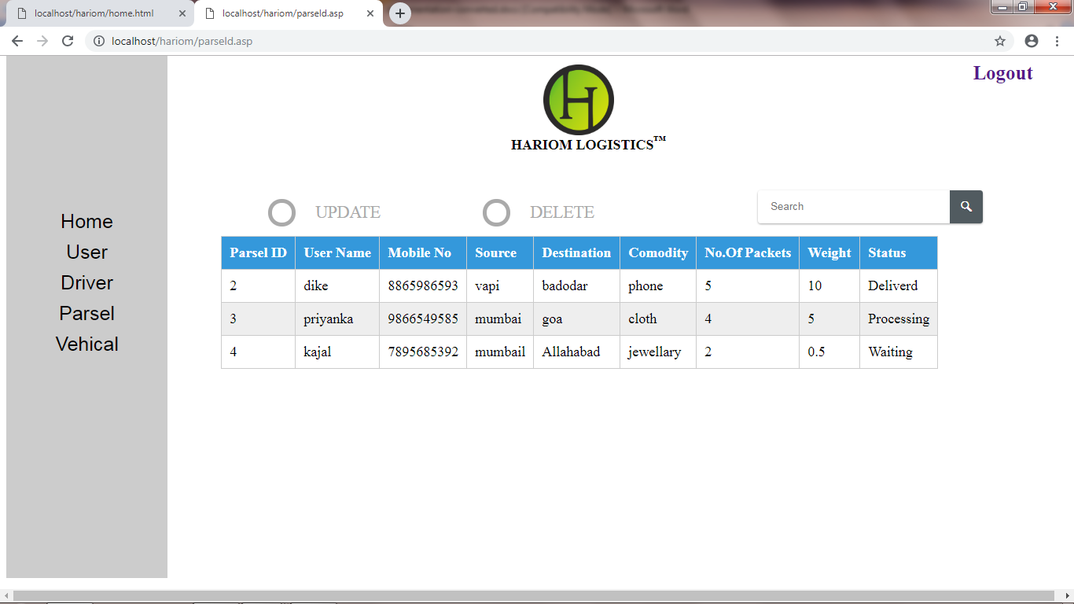

**Vehicle Details (admin)**

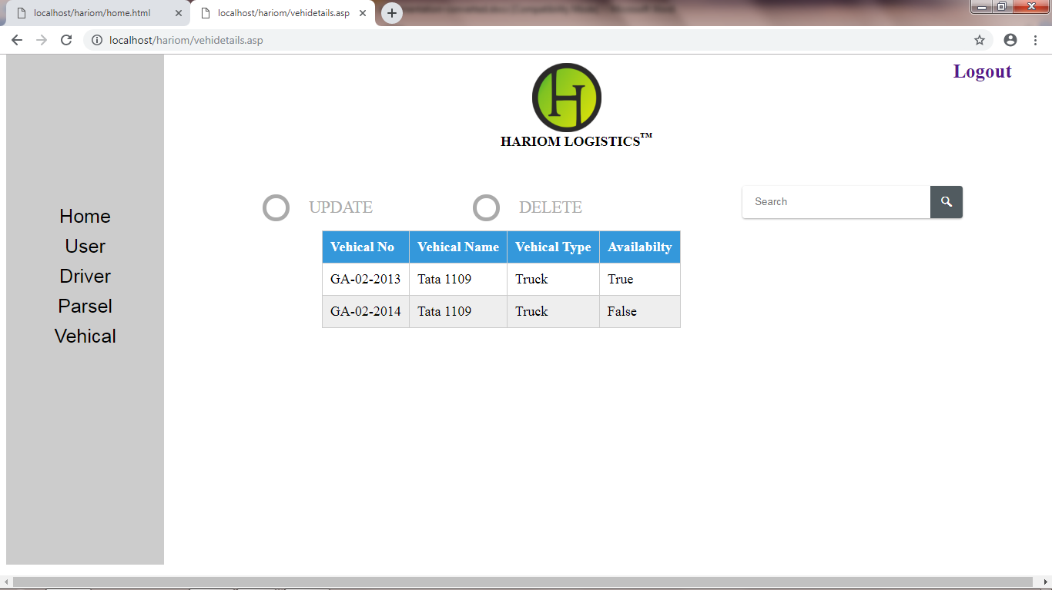

**Booked Vehicle Details (Admin)**

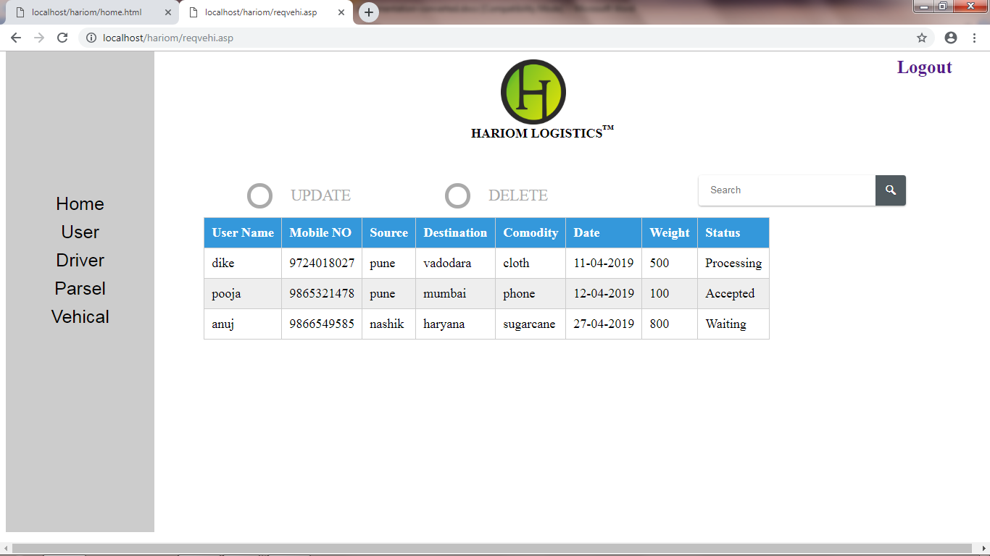

**Sample Code**

**<html>**

**<head>**

**<link rel="Stylesheet" type="text/css" href="cs.css">**

**<link rel="Stylesheet" type="text/css" href="effectpic.css">**

**</head>**

**<body>**

**<span>**

**<div id="soc">**

**<div class="topnav">**

**<div class="topnav-right">**

**<a><i class="fas fa-envelope"></i>HariOmlogistiocs@gmail.com</a>**

**<a><i class="fas fa-phone-square"></i>+91 9322697712</a>**

**<a><i class="fas fa-map-marked-alt"></i>Shiv Shankar Yadav</a>**

**</div>**

**</div>**

**<div class="bottomnav">**

**<div class="bottomnav-right">**

**<a href="home.html"target="a" class="active">Home</a>**

**<a href="about.html"target="a" >About us</a>**

**<a href="service.html">Services</a>**

**<a href="network.html">Network</a>**

**<a href="whyhol.html">Why HOL?</a>**

**<a href="Login.html">Logout</a>**

**</div>**

**</div>**

**<div class="logo">**

**<img src="Logo.png">**

**<h1 id="name">HARI OM LOGISTICS Pvt.Ltd.<sup>&trade;</sup></h1>**

**</div>**

**</div>**

**</span>**

**<div id="bodycont">**

**<img src="truck.jpg" height="500px" width="900px">**

**<img src="laeding.png" height="500px"><br><br><br>**

**&nbsp;&nbsp;&nbsp;&nbsp;&nbsp;&nbsp;<img src="state.png" width="1300px">**

**<div class="grid">**

**<figure class="effect-steve">**

**<img src="cargo.jpg" alt="img29"/>**

**<figcaption>**

**<h2><span>PARCEL</span></h2>**

**<p><a href="cargo.html">Send Parcel</a></p>**

**</figcaption>**

**</figure>**

**<figure class="effect-steve">**

**<img src="book.jpg" alt="img33"/>**

**<figcaption>**

**<h2><span>VEHICALS</span></h2>**

**<p><a href="vehical.html">Book Vehical</a></p>**

**</figcaption>**

**</figure>**

**</div>**

**</div>**

**<hr>**

**<br>**

**<center>**

**<img src="Logo.png" width="50px" height="50px"><br>**

**<br>**

**<p1>Sanjaynagar near Hema Industrises, Anderi (East) Mumbai 400093</p1><br>**

**<p3> (91) 958-851-5151 | info@holgroup.com</p3></br>**

**<p2>(022) 234 45151 | (022) 234 50551</p2><br>**

**<br>**

**<p4>Copyright 2019 &copy; Hari Om Logistics Transport Co. Pvt. Ltd.</p4>**

**</center>**

**</body>**

**</html>**